|  |  |  |  |  |
| --- | --- | --- | --- | --- |
| **Bug ID** | **Description/Summary** | **Steps to Reproduce** | **Expected Result** | **Actual Result** |
| **Let's Chat Bug 01** | **User is not redirected to OTP Page when user uses phone number of 4 digit which is the phone number length in Niue** | **1. Click on the Phone Number Field** | **1. User Should be redirected to OTP Page** | **User is not redirected to OTP Page** |
| **2. Enter the Phone number with 4 digits** | **2. User Should Receive the OTP** |
| **3. Accept the Terms and Conditions and Privacy Policy** |  |
| **4. Click on the' ->' icon to continue** |

**Link To The Github Page -** [**https://github.com/Abhishekkaddipudi123/Letschat-app-Manual-Testing**](https://github.com/Abhishekkaddipudi123/Letschat-app-Manual-Testing)

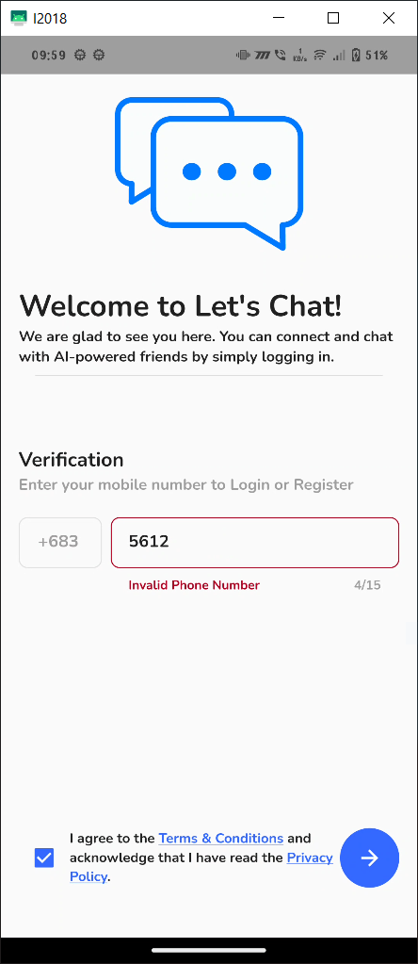

|  |  |  |  |  |
| --- | --- | --- | --- | --- |
| **Let's Chat Bug 02** | **the user's chats are not preserved when we logout and log in with same account** | **1. Login with valid credentials and chat with some bots** | **the user's chats must be preserved** | **the user's chats are not preserved** |
|  | **2. go to the hamburger menu, Press the logout button and confirm the log out** |

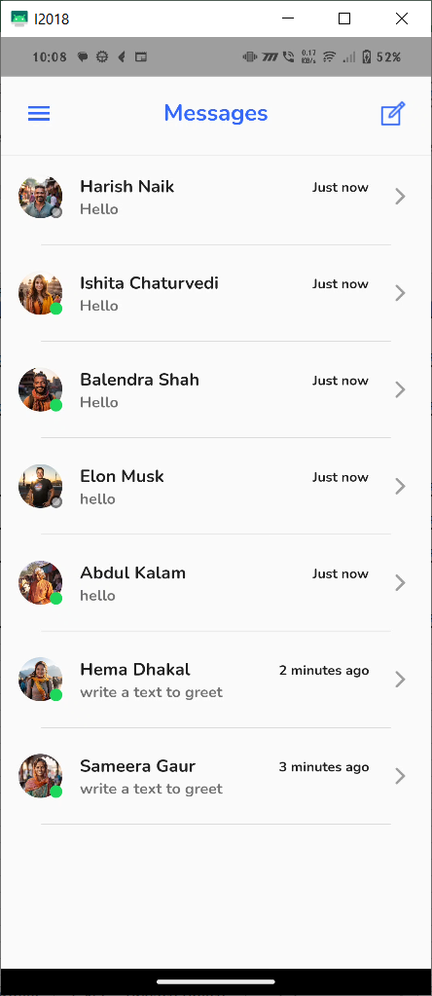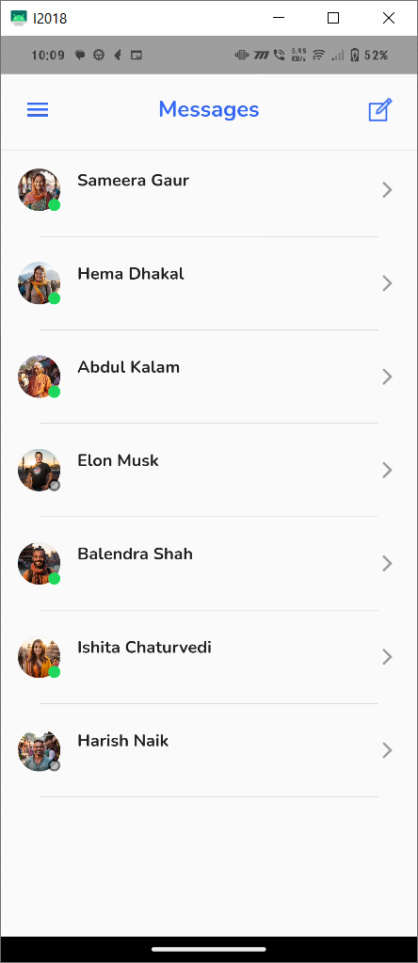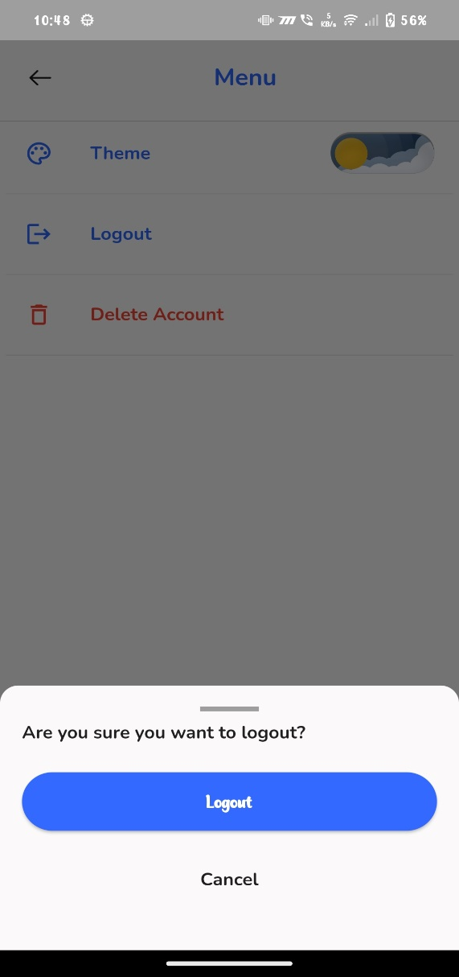

|  |  |  |  |  |
| --- | --- | --- | --- | --- |
| **Let's Chat Bug 03** | **User did not get any reply when chat with bot** | **1. Login with valid credentials** | **bot must reply to the user and Notification Must be received by the user** | **no reply and notification is sent by the bot** |
| **2. send a message and wait for reply and Check for the notification of New Messages** |

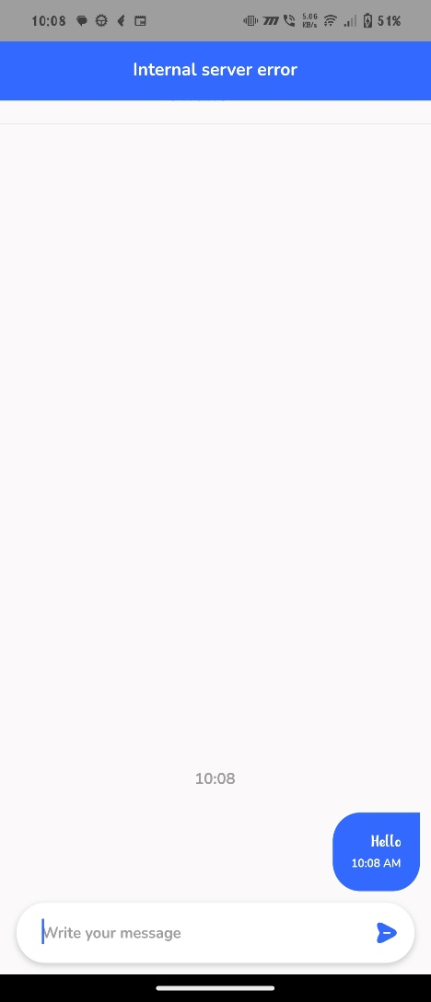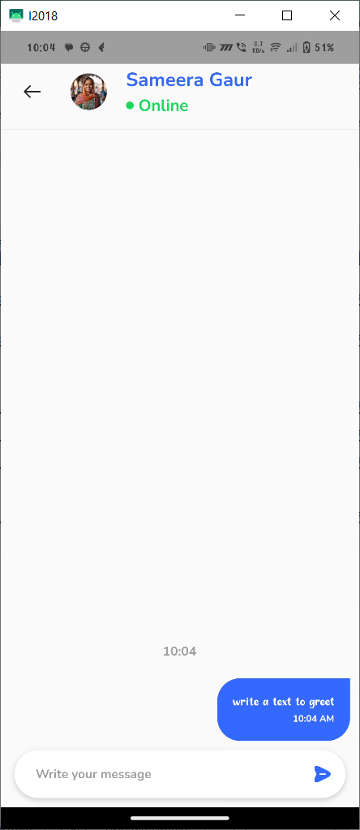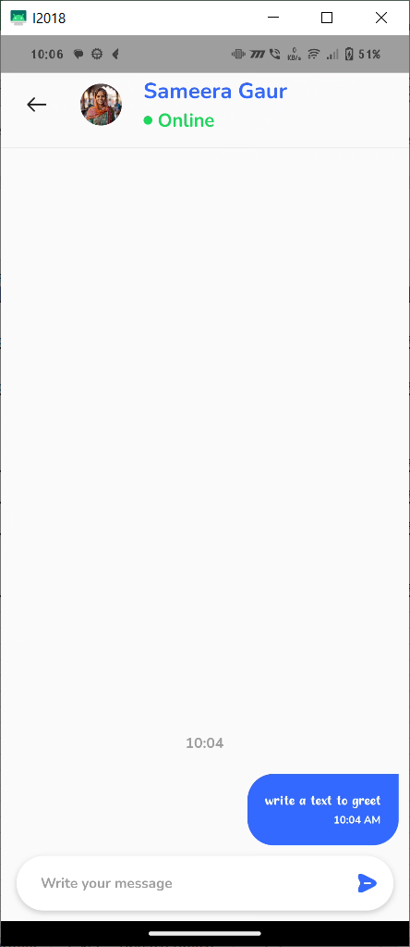

|  |  |  |  |  |
| --- | --- | --- | --- | --- |
| **Let's Chat Bug 04** | **The User is not redirected to Terms and Conditons page when clicked on terms and conditions hyper link** | **Click On the 'Terms and Conditions' text from the footer of page** | **The User must be redirected to Terms and Conditons page** | **The User is not redirected to Terms and Conditons page** |
|  |

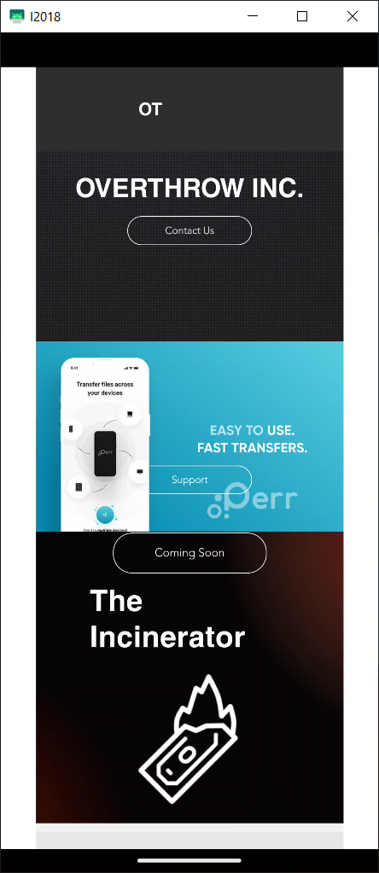

|  |  |  |  |  |
| --- | --- | --- | --- | --- |
| **Let's Chat Bug 05** | **The User is not redirected to contact us mail when clicked on contact us button in terms and conditions page** | **Click On the 'terms and conditions' text from the footer of page** | **The User Must Be redirected to Mail app with a composing a new mail to contact us mail** | **The User is not redirected to Mail app** |
|  | **Click on the contact us Button** |

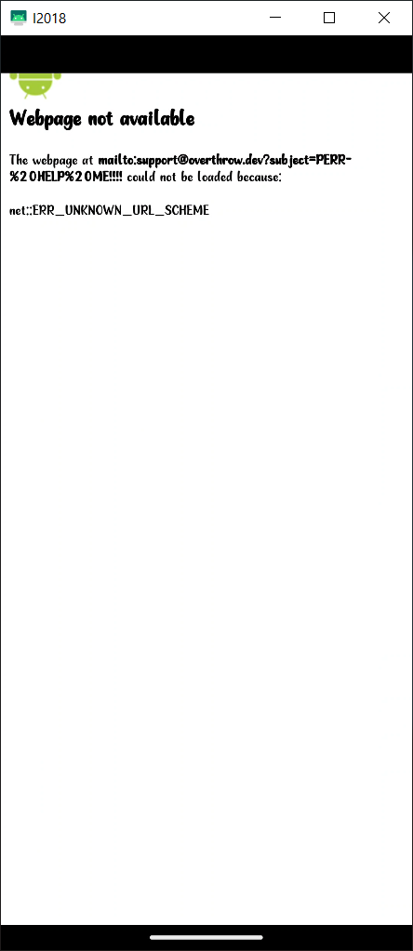

|  |  |  |  |  |
| --- | --- | --- | --- | --- |
| **Let's Chat Bug 06** | **The User is not redirected to support mail when clicked on support button in terms and conditions page** | **Click On the 'terms and conditions' text from the footer of page** | **The User Must Be redirected to Mail app with a composing a new mail to support mail** | **The User is not redirected to Mail app** |
|  | **Click on the support Button** |

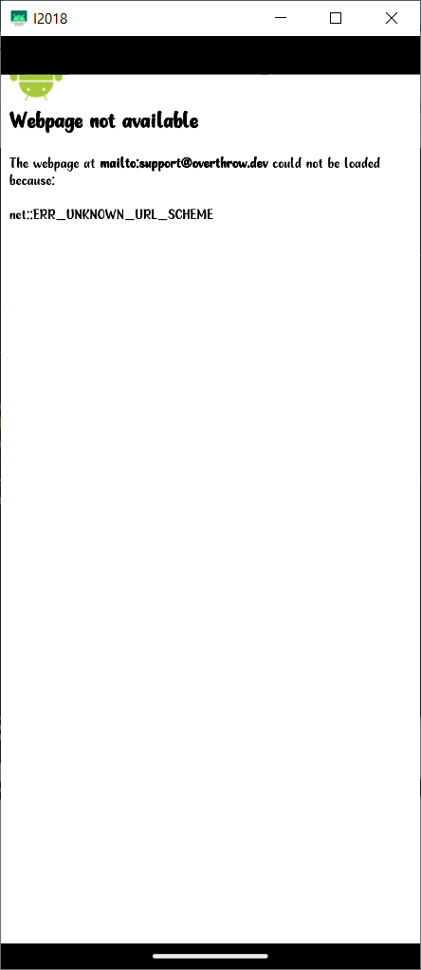

|  |  |  |  |  |
| --- | --- | --- | --- | --- |
| **Let's Chat Bug 07** | **The User is not redirected to Privacy Policy page when clicked on Privacy Policy hyper link** | **Click On the 'Privacy Policy' text from the footer of page** | **The User Must Be redirected to Privacy Policy page** | **The User is not redirected to Privacy Policy page** |
|  |



|  |  |  |  |  |
| --- | --- | --- | --- | --- |
| **Let's Chat Bug 08** | **The User is not redirected to contact us mail when clicked on contact us button in Privacy Policy page** | **Click On the 'Privacy Policy' text from the footer of page** | **The User Must Be redirected to Mail app with a composing a new mail to contact us mail** | **The User is not redirected to Mail app** |
|  | **Click on the contact us Button** |



|  |  |  |  |  |
| --- | --- | --- | --- | --- |
| **Let's Chat Bug 09** | **The User is not redirected to support mail when clicked on support button in Privacy Policy page** | **Click On the 'Privacy policy' text from the footer of page** | **The User Must Be redirected to Mail app with a composing a new mail to support mail** | **The User is not redirected to Mail app** |
|  | **Click on the support Button** |

